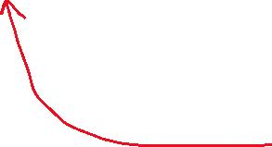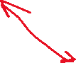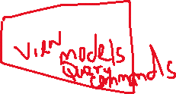

C – Command model. Any data coming from a query form(BLL) that needs to be stored in the database is a command data.

Q – This is the query. That is the data coming from the database to be displayed on the form(BLL).

R – Responsibility of the models( C and Q)

S – Segregation – To separate the responsibilities.

For this course, we need to know how to handle our methods – transactions.